Angular - Custom Route Matches

What is Custom Route Matches?
In Angular, the custom route matches allow you to define a "specific condition" under which certain routes are matched. This is useful while controlling the application navigation when the URLs are more complicated.

Creating Custom Route Matches
The router in Angular supports a powerful matching strategy that you can use to help users navigate various sections in your application. This matching strategy supports static routes, variable routes with parameters (i.e., /:parameter), wildcard routes (i.e., **), and so on. Also, you can build your own custom pattern matching for situations in which the URLs are more complicated.
In this chapter, we will build a custom route matcher using AngularUrlMatcher. In Angular, UrlMatcher is a "function" used to define custom URL-matching logic for routes.
Let's create a sample Angular application to perform the creation of the custom router matcher.

Creating a Sample Application
We will use the Angular CLI to create a new sample application named angular-custom-route. In addition to the application creation, we will create a dashboard component.
Note: Make sure the Angular CLI is installed.
- Create a new Angular project, app-custom-route.
You should be in VS Code open the folder now.
- From Terminal, Create a component with the name dashboard
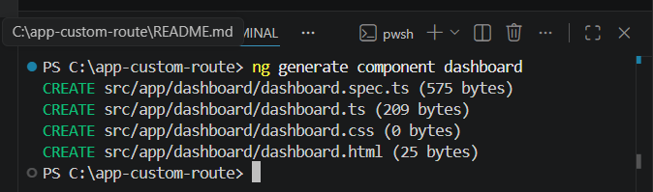
- In your code editor locate the app.html file, and replace the below code with:
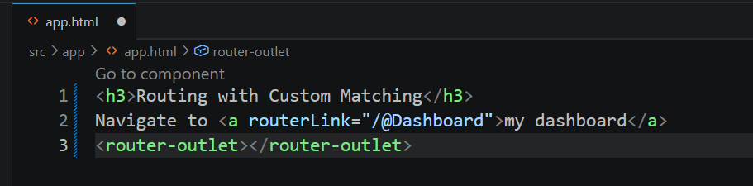
- In your code editor open the dashboard.html file and replace the below HTML code:
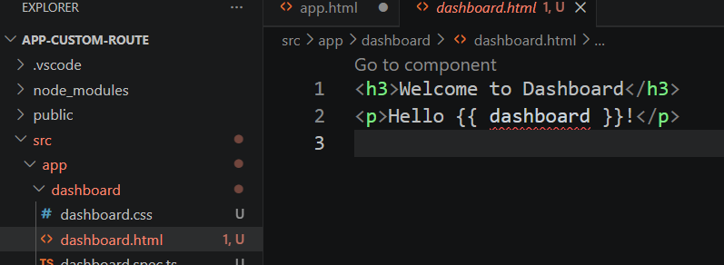

Configure Routes for your Application
Next, you need to add routing capabilities to the app.config.ts file. As a part of this process, we will create a custom URL matcher that looks for a Twitter handle in the URL. This handle is identified by a preceding@symbol.
- In the app.routes.ts, change it to
import { Routes, UrlSegment } from '@angular/router';
import { Dashboard } from './dashboard/dashboard';

export const routes: Routes = [
{
matcher: (url) =>{
if(url.length === 1 && url[0].path.match(/^@[\w]+$/gm)){
return {
consumed: url,
posParams: {
dashboard: new UrlSegment(url[0].path.slice(1), {})}};
}
else{
return null;
}
},
component: Dashboard
}
];

- In your IDE (code editor) open the app.config.ts file, chance it to
import { ApplicationConfig, provideBrowserGlobalErrorListeners } from '@angular/core';
import { provideRouter } from '@angular/router';

import { routes } from './app.routes';

export const appConfig: ApplicationConfig = {
providers: [
provideBrowserGlobalErrorListeners(),
provideRouter(routes)
]
};

- Save all files

As we know the custom matcher is a function which is performed the following tasks as follws:
- The matcher verifies that the array contains only "one" element.
- The matcher uses a regular expression to ensure that the format of the "dashboard" is a match.
- If there is a match found, the function returns the "entire URL", defining a dashboard route parameter as a substring of the path.
- If there is no match found, the function returns null, and the router continues to "look for other routes" that match the URL.

Reading the Route Parameters
As we created a link in our app.html file to redirect to the dashboard component, now we will bind the route parameter with the Dashboard component.
- Open the dashboard.ts file in your code editor and create an Input matching the dashboard parameter.
import { Component, Input } from '@angular/core';

@Component({
selector: 'app-dashboard',
imports: [],
templateUrl: './dashboard.html',
styleUrl: './dashboard.css'
})
export class Dashboard {
@Input() dashboard!: string;
}
Note: As we imported withComponentInputBinding in our provideRouter. It will allow the Router to bind information directly to the route components.
- Save all files.
- Now run your application to check your custom URL matcher as follows:
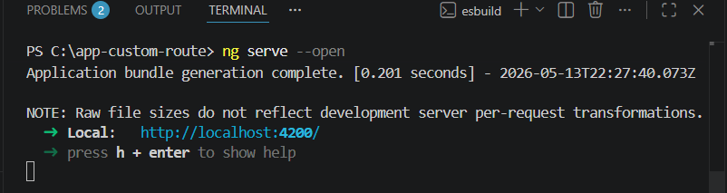
The browser shows
